Group no: 7

1. Faiza Tasnim-(19-41552-3)
2. Syeda Faiza Karima-(20-43073-1)
3. Sharia Tasnim Adrita-(20-41895-1)
4. Sadia Afrin Sara – (20-41834-1)

**Activity diagram:**

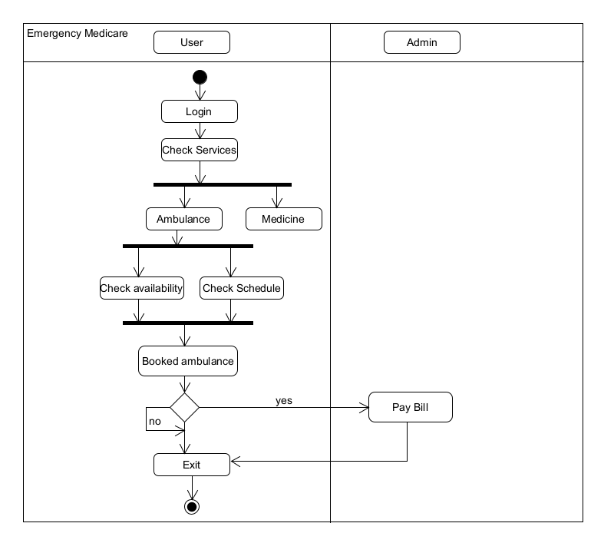

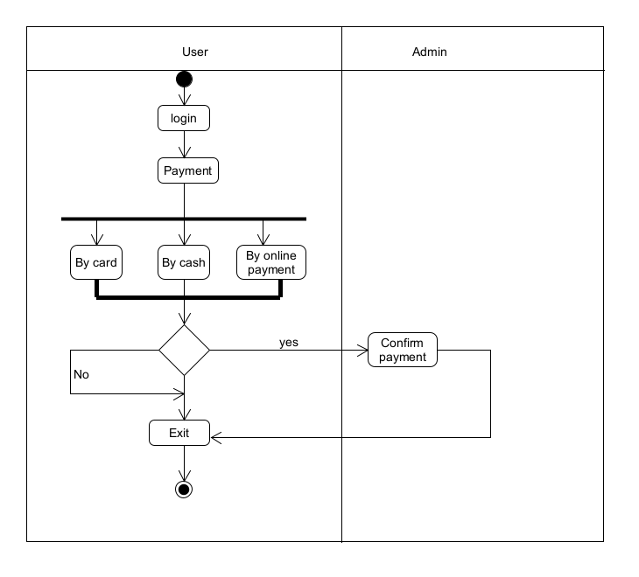

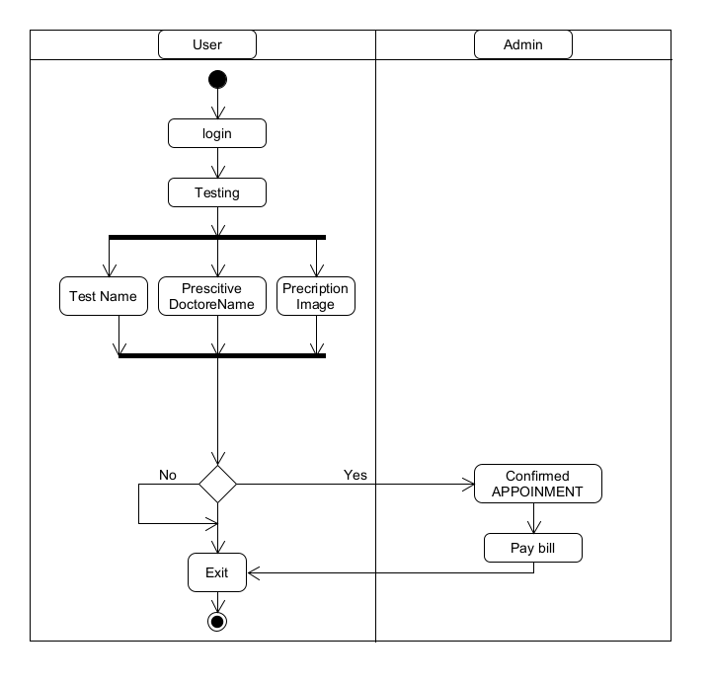

**CRC DIAGRAM:**

|  |  |
| --- | --- |
| Class Name : User | |
| Subclass : | |
| Superclass : Permission. | |
|  | |
|  | |
| Responsibilities | Collaborators |
| Create profile | Booking |
| Checking Services | Payment |
| Checking Availability | Permission |
| Checking Schedule | Ambulance |
| Booking ambulance | Testing |
| Manage Payment | Medicine |
| Preorder medicine |  |
| Testing |  |

|  |  |
| --- | --- |
| Class Name : Admin | |
| Subclass : | |
| Superclass : | |
|  | |
|  | |
| Responsibilities | Collaborators |
| Manage user | Booking |
| Manage and Collect Payment | Payment |
| Confirm Payment |  |
| Testing |  |
| Confirm Booking |  |